Town of La Grange, Monroe County
Mandy Wagner, Treasurer www.TownofLaGrangeMCWI.gov Ph: 608.387.4193
2025 PROPERTY TAX COLLECTION – IMPORTANT INFORMATION
General Information:
- I will accept real estate tax payments between now and January 31, 2026.

- I will NOT accept cash.

- Make ALL checks payable to TOWN OF LA GRANGE (between December 2025 – January 31, 2026). **Do not add my name on the payee line. **

- All first installments are due by 1/31/26. You may pay your taxes in full. I will accept postmarks.

- Please include your phone number on checks so that I may contact you if there are issues with the payment.

- After January 31, 2026, ALL payments must be made payable & sent to: Monroe County Treasurer

Acceptable Payment Options:
- Online: **NEW OPTION THIS YEAR**
Please see page 2 of this document. Scan QR code to reach payment site

2. Mail to: Mandy Wagner
25870 County Highway G
Tomah, WI 54660

3. In-Person Office Hours at the Town Hall, 22731 Flint Ave, Tomah, WI 54660
*Changes to Location Hours will be posted on the LaGrange Town Hall Facebook Page.

2025 | 2026
Friday, December 19, 5:00 pm – 6:30 pm | Friday, January 16, 5:00 pm – 6:30 pm
Saturday, December 27, 8:00 am – 10:00 am | Sunday, January 25, 11:00 am – 1:00 pm
Wednesday, December 31,  7:00 am – 9:00 am & 3:30 pm – 5:00 pm | Saturday, January 31,  7:00 am – 9:00 am & 4:00 pm – 6:00 pm

Unacceptable Payment Options:
I will NOT accept payments in person at my home under any circumstances. Mail payments or stop in during office hours. Thank you.

Dog Licenses | I will be accepting payment for dog licenses as well. Proof of current rabies vaccine is REQUIRED and you must Include a self-addressed, business-size, stamped envelope so I may mail you the dog tag. No CASH or CREDIT.
Receipts for mailed payments | If you mail your payment and want a receipt, you MUST include a self-addressed, business-size, stamped envelope with your payment. If paid by a lender or through escrow, mail me a self-addressed, business-size, stamped envelope and a note asking for a receipt.
Tax Roll/Booklets | Due to the change in tax collection software, a printed tax roll/list is no longer available. A full copy will be linked on our website and printed to view at the town hall or you can view the information on Monroe County’s Land Information Office website under Online GIS & Property Information.
ONLINE PAYMENTS:

Town of LaGrange (Monroe County) is accepting online payments this tax year through the Monroe County Treasurer’s Public Portal. The website address is: https://pp-monroe-co-wi-fb.app.landnav.com/Login (or scan the QR code) and choose Guest Sign In. Fees are associated with online payments and are subject to change. As of 9/23/25, the fees are as follows:

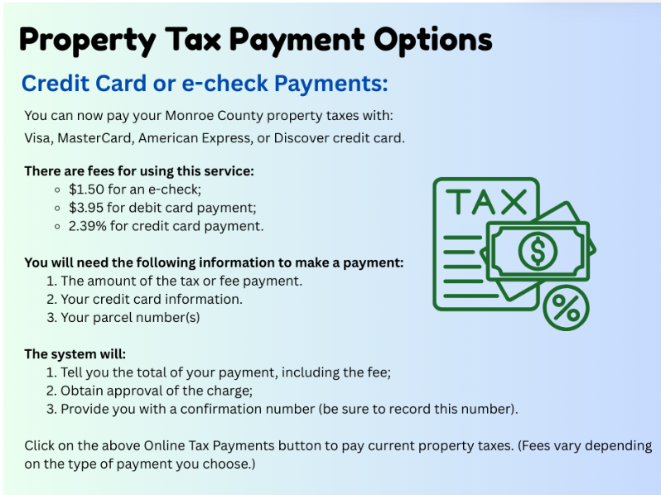

Please see the Monroe County Treasurer’s website at https://www.co.monroe.wi.us/departments/treasurer for instructions on how to use the online payment portal and other relevant property tax information.

TAX OVERPAYMENTS:

The Town of La Grange board adopted an ordinance regarding the refund of certain overpayments to the town. This ordinance states that a nominal overpayment is an amount which does not exceed $10.00. The Town will retain nominal overpayments unless the payer requests a refund. Please refer to our website, TownofLaGrangeMCWI.gov, for the full ordinance. Ordinances are found under the “Government” menu, then Ordinances.

